On the beat in  Wem  Safer Neighbourhood Team Newsletter | September 2023

Who we are
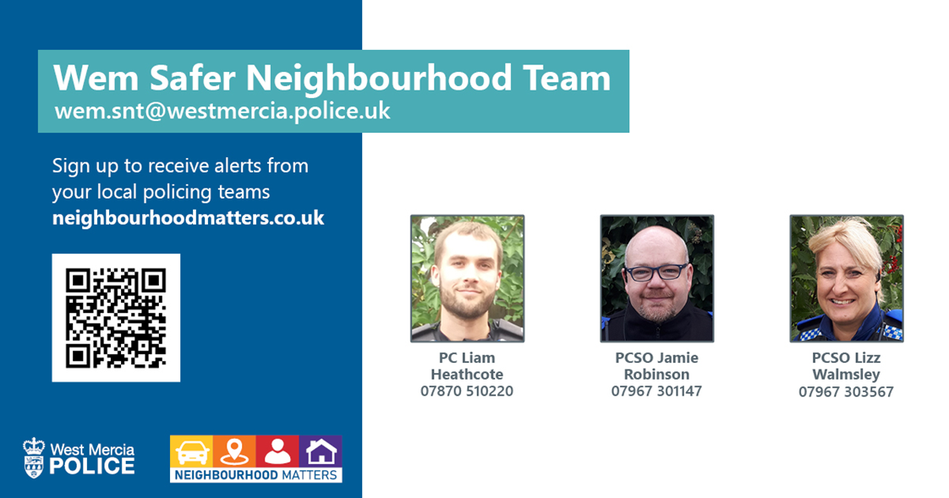

Sign up to Neighbourhood Matters … your brand new community messaging service
Neighbourhood Matters enables residents, businesses and community groups to keep in touch with local policing teams. You can choose exactly what type of alert you wish to receive and how you receive them; whether that be by email, text or telephone.
Sign up now at: www.neighbourhoodmatters.co.uk

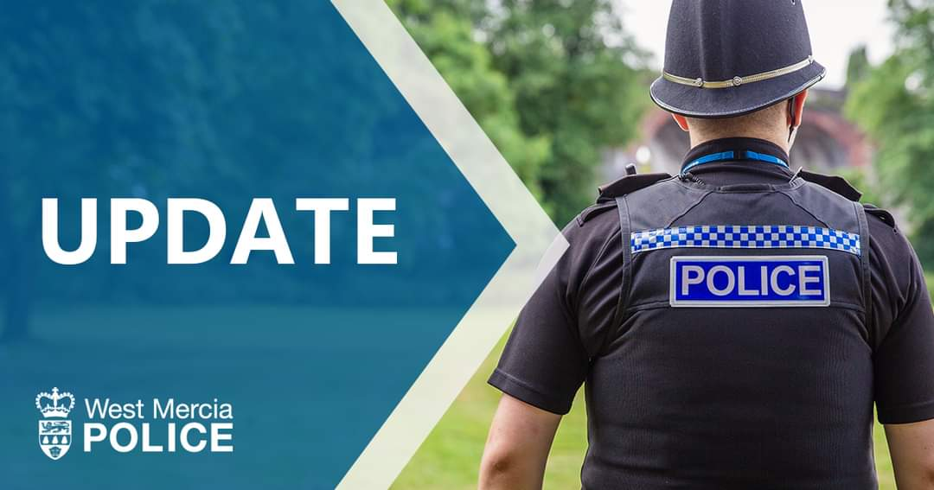

Police Incidents.

Burglary- 0
RTC- x 11
Vehicle Crime- x 2
Highways Incident- x 21
Assaults- x 20
Domestic incidents- x 11
Concern for safety- x 18
Anti-Social Behaviour- x 8
Suspicious Circumstances x 26
Criminal Damage x 2
Theft x 5
Missing Persons- x4

. SNT officers were involved when a warrant was carried out at a restaurant on Wem High Street on August 4th. Three males were arrested om charges relating to drug supply.
. Work conducted by Wem SNT supporting the Serious Acquisitive Crime Team led to the quick arrest of a male in connection to a burglary which took place at Wards General store on Wem High Street.
Support from the community and the store owners was pivotal in in the speediness of the arrest.
Other News

West Mercia is looking for volunteers to join StreetWatch scheme.

What is StreetWatch?
StreetWatch is a community led watch scheme which allows you to make a difference where you live.
It is made up of groups of volunteers from our local communities who carry out street walks but have no police powers.
It allows local people to help improve the neighbourhoods they live in by walking their own streets and providing visible reassurance and appropriate engagement in local issues that matter most.
The groups are managed by a coordinator, who keeps a volunteer list, provides advice, guidance and support and is usually the contact that speaks with the local policing team.
What will you get out of it?
Becoming a StreetWatch Volunteer is a fantastic way to help keep your community safe, to meet new people in your community who share the same values, improve community engagement with the police, and to keep fit and healthy.
You will be provided with suitable training and high vis jackets before your first walk, as well as lamp post, window and wheelie bin stickers which can you display within your community.
What we need from you?
As a Street Watch member, you will patrol your local area for at least two hours every month, at times which suit you. You will patrol in a minimum of two members, talk to people you meet and encourage them to take an active interest in keeping your area safe.
If the group sees suspicious activity, they will report it to the local policing team, but will not get involved.

