 | On the beat in…  North Shropshire  Market Drayton  Wem  Whitchurch  Safer Neighbourhood Team Newsletter | December  2024

Current statistics on calls to police and crime recording for your neighbourhood can be found at www.police.uk. If you wish to discuss further, please contact a member of your Safer Neighbourhood Team.

Market Drayton – Team contact details:
Team email: marketdrayton.snt@westmercia.police.uk
Safer Neighbourhood Officer: PC Iain McIntosh Mobile: 07811 748 732
Police Community Support Officer: PCSO Andy King Mobile: 07870 163 116
Police Community Support Officer: PCSO Tara Carruthers Mobile: 07971 050 442
Police Community Support Officer: PCSO Richard Parker Mobile: 07483 123 858

Wem – Team contact details:
Team email: wem.snt@westmercia.police.uk
Safer Neighbourhood Officer: PC Jack Harper Mobile: 07817 885 113
Police Community support Officer: PCSO Lizz Walmsley Mobile: 07967 303 567
Police Community support Officer: PCSO Olly Morris Mobile: 07970 879 117

Whitchurch – Team contact details:
Team email: whitchurch.snt@westmercia.police.uk
Safer Neighbourhood Officer: PC Ben Jones Mobile: 07973 885 557
Police Community Support Officer: PCSO Jamie Robinson Mobile: 07967 301 147
Police Community Support Officer: PCSO Dave Andrew Mobile: 07971 395 050
Police Community Support Officer: PCSO Sarah Parker Mobile: 07483 121 957

Our North Shropshire Parish Councils and their chosen priorities:
Market Drayton |  | Wem |  | Whitchurch
Market Drayton Town | Drugs | Wem Town | Speeding | Whitchurch Town | Drugs
 | ASB |  | ASB |  | ASB
 | Not provided |  | Thefts (Other) |  | ASD
Adderley | Thefts (Farm) | Wem Rural | Rural Crime | Whitchurch Rural | Speeding
 | Speeding |  | Drugs |  | Thefts (Outbuilding)
 | Not provided |  | Speeding |  | Other Traffic Offences
Cheswardine | ASB | Hadnall | Speeding | Prees | Other Traffic Offences
 | Dwelling thefts |  | ASB |  | ASB
 | Not provided |  | Thefts (Out bldg) |  | Thefts (Farms)
Hinstock | Speeding | Shawbury | Speeding | Whixall | ASD
 | Thefts |  | ASB |  | Thefts (Farms)
 | RTC |  | Drugs |  | Thefts (Out bldg)
Hodnet | Speeding | Clive | ASB | Ightfield with Calverhall | Thefts (Farms)
 | Not provided |  | Other Traffic offences |  | ASB
 | Not provided |  | Thefts (Other) |  | Not provided
Moreton Say | Thefts (Farms) | Grinshill | Speeding
 | ASD |  | ASB
 | Speeding |  | Thefts (Other)
Norton In Hales | Not provided | Myddle, Broughton & Harmer Hill | ASB
 | Not provided |  | Criminal Damage
 | Not provided |  | Speeding
Stanton Upon Hine Heath | Speeding | Lee Brockhurst & Moreton Corbett | Thefts (Farm)
 | Thefts (Farm) |  | Speeding
 | Not provided |  | Other Traffic Offences
Stoke On Tern | Speeding | Loppington | Not provided
 | Thefts (Farms) |  | Not provided
 | Wildlife Crime |  | Not Provided
Sutton Upon Tern | Speeding
 | Thefts (Farms)
 | Thefts (Commercial)
Woore | Speeding
 | Theft (farm)
 | ASB
Childs Ercall | Speeding
 | Thefts (Farm)
 | ASB
Weston Under Redcastle | Not provided
 | Not provided
 | Not provided

Please encourage your parishioners to sign up to Neighbourhood Matters.

Sign up to Neighbourhood Matters… your brand-new community messaging service
 | Neighbourhood Matters enables residents, businesses, and community groups to keep in touch with local policing teams. You can choose exactly what type of alert you wish to receive and how you receive them; whether that be by email, text or telephone.  Sign up now at: www.neighbourhoodmatters.co.uk

Hello Parish Councils,

This is your North Shropshire Safer Neighbourhood Team (SNT) Newsletter for December 2024. Please see the link above to police.co.uk for crime recording stats for your area, or any other area in the UK should you wish.

Please get in touch if you would like to discuss anything further, if we can provide more information we will, our contact details are above. If there is anything specific that is affecting your parish area above and beyond the three priorities you have nominated, again please let us know and we will endeavour to support you.

The official West Mercia Police website www.westmercia.police.uk has a wealth of information and includes dedicated sections in relation to News, Recruitment, Watch Schemes, Neighbourhood Matters, Crime Prevention Advice, Support For Victims, other Advice and Information and Thanks & Complaints.

Our North Shropshire SNTs work in a very challenging and varied role and no two days are the same, naturally there are many requests for our time, support and assistance. Obviously, much of what we do we can’t tell you too much about, but rest assured that much of our focus is on the three Parish Council Priorities that you provide us with quarterly.

Much of the good work that SNTs engage with are posted in the following places:

- Parish Council reports in person or Newsletters

- Neighbourhood Matters – www.neighbourhoodmatters.co.uk

- Facebook - www.facebook.com/shropshirecops/

- Twitter – www.twitter.com/NorthShropCops

Below is just a small snapshot of the good work North Shropshire SNTs have been involved with recently…

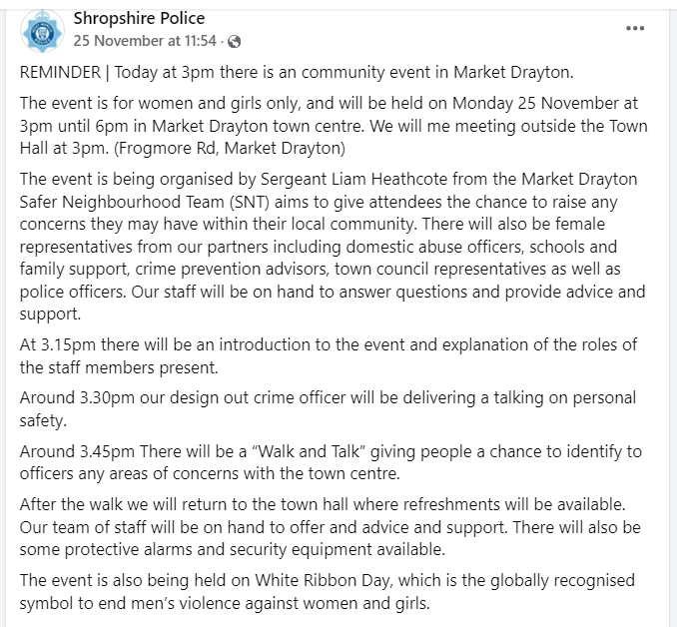

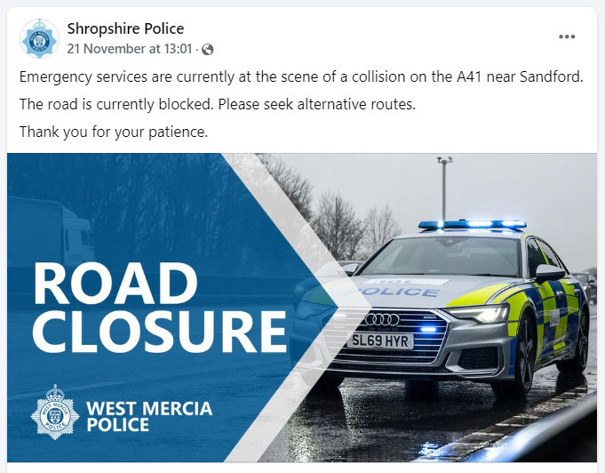

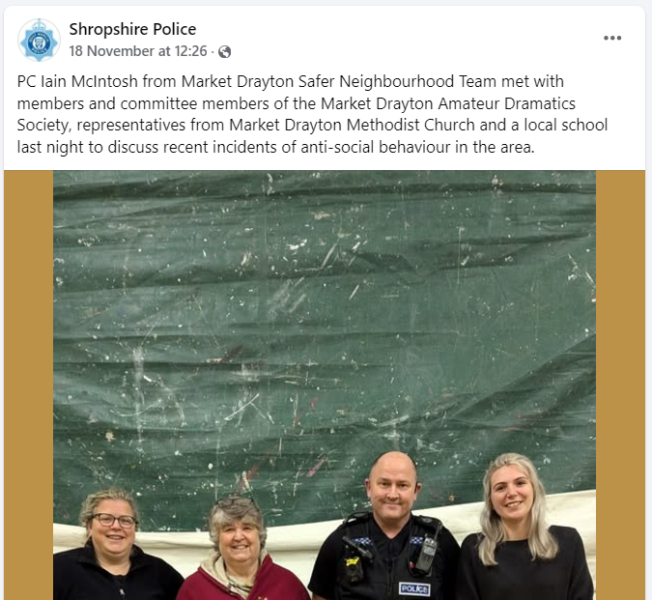

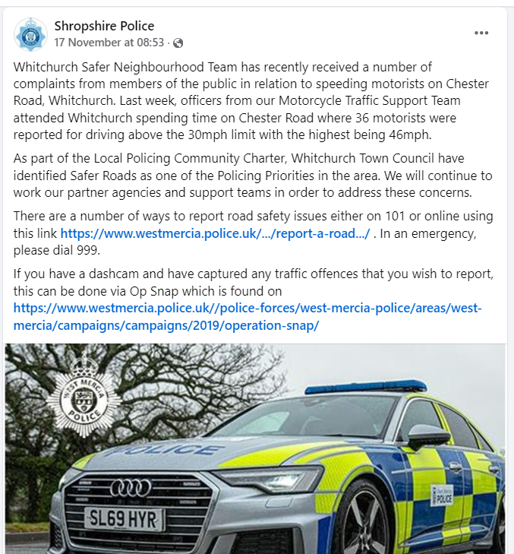

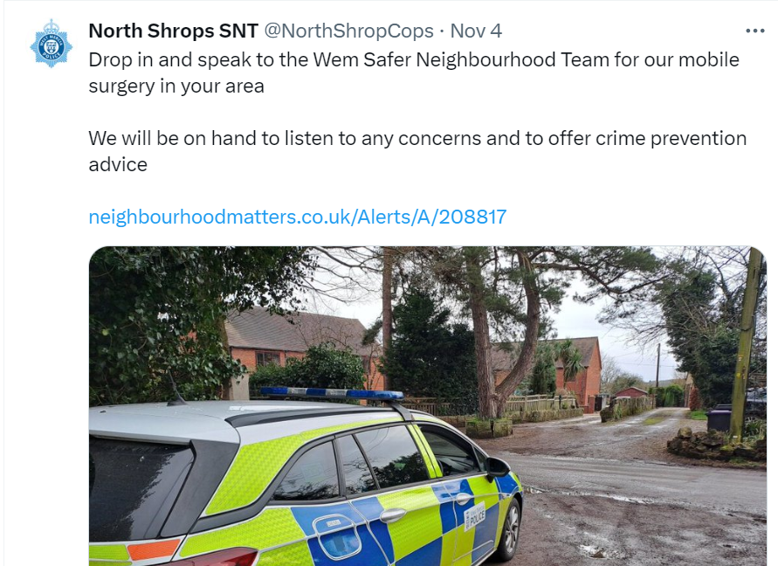

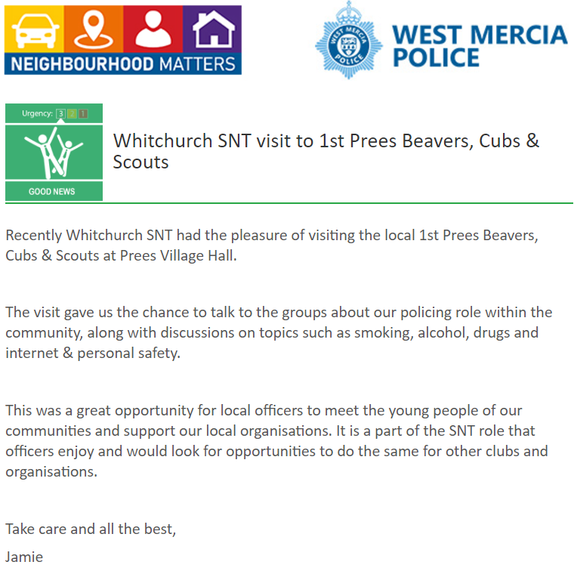

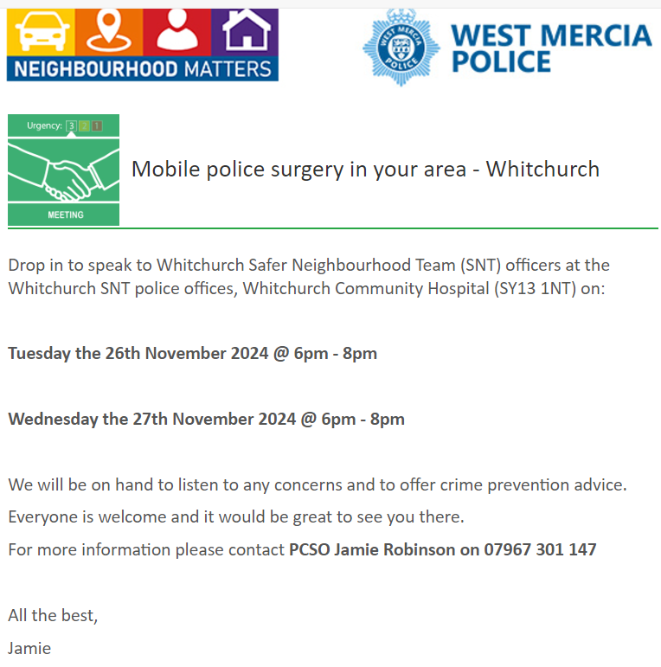

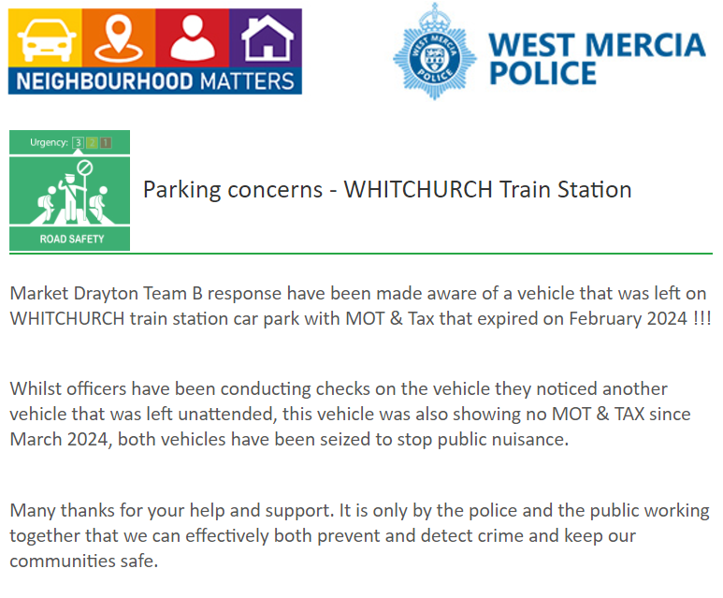

As part of the monthly Newsletter, we will be adding trending and/or appropriate crime prevention advice and information. Along with any recent updates from our other policing departments and partners.

This month’s Newsletter contains sections on ‘Nottingham Knockers’ (current North Shropshire trend), ‘Crash for cash’ (current national trend), ‘Christmas Drink Drive’ (seasonal message)

Nottingham Knockers

NOT SURE? DON'T OPEN THE DOOR!

We have had reports that ‘Nottingham Knockers’ are attending homes in North Shropshire recently. Be vigilant. Stay Safe. Do not buy or sell anything at the door.

Who are the Nottingham Knockers?
Nottingham Knockers are usually young men who go door to door, selling household products. They are often dropped off early in the morning in a particular location by a large van and are then transported around that area throughout the day.

What is the scam?
They may offer to show you a fake company I.D for a company that does not exist. They may also be carrying a large holdall style bag which contains various household items at high prices and will try and hard sell to make money. They will also tell you about how they are trying to make a better life. When you decline their advances, you may be subject to verbal abuse and threats to cause criminal damage.

If you get an unexpected knock on the door, please check to see who is on the other side of your door before opening it. Either look through a side window, look through a spy hole, or simply ask out loud who it is. If you do not know them, establish who they are and what they are there for before you open the door. Please remember if the cold caller sales are unsuccessful, they are unlikely to return in future.

If you do experience any verbal abuse and feel intimidated, please call 101 and tell us what was said, and a description of the person.

If you would like a 'No Cold Callers' poster for your door, email your local Safer Neighbourhood Team via the contact emails above and we will drop one round for you.

Crash for cash
‘Crash for cash’ is a form of insurance fraud in which drivers and moped riders stage road traffic collisions to gain compensation. These collisions put motorists at risk and contribute to increased insurance premiums.
There has been a rise in ‘crash for cash’ fraud involving mopeds in the UK. Over 4,000 people were targeted from June 2021 to July 2024, leading to fraudulent insurance claims worth an estimated total of £70 million.
Organised criminal gangs are often behind these incidents and will make fake or exaggerated insurance claims for storage and replacement moped costs. In some cases, fraudsters will cause a crash and try to intimidate victims into handing over money at the scene.

What to look out for
- Beware of single parked vans near junctions. ‘Crash for cash’ moped riders often use them as hiding spots.
- Be wary of moped riders loitering or acting suspiciously in residential areas. Often, they will hang around in small roads off busy high streets before staging a collision.
- ‘Crash for cash’ fraudsters overreact and fake injuries after crashes.
- Moped riders will often keep their helmets on after a collision to avoid identification.

How to protect yourself against ‘crash for cash’ fraud
- Be cautious when on the road and give all drivers adequate distance in front and behind.
- Fitting a dashcam to the front and rear of your vehicle can help deter offenders. If you become victim to, or witness, a ‘crash for cash’ incident, dashcam footage may help prove that an insurance claim is fraudulent. It could also help the police prosecute offenders.
- If you see a suspicious crash, offer to be a witness to the driver. Gather as much information as possible. This could be the make and model of the moped, its number plate or the clothing the moped rider is wearing.
- ‘Crash for cash’ moped riders may try to pressure you into presenting your driving licence and insurance certificate after a collision, which they will photograph on their mobile phone. In some instances, the information on these documents has been used to fraudulently take out insurance policies. Protect your ID from being compromised by only providing the other driver with the insurance information that is legally required.
If you are involved in, or witness, a collision and suspect it is a ‘crash for cash’ incident, report it to the police via the Insurance Fraud Bureau’s confidential CheatLine on 0800 422 0421 or insurancefraudbureau.org/cheatline. Always call 999 in an emergency.

Christmas Drink Drive
Over the past three years across our three counties there have been 25 fatalities and 167 serious injuries on the roads where alcohol has been a contributory factor. An additional 11 fatalities and 68 serious injuries have occurred involving drugs. Whilst the vast majority of drivers do the right thing, across the three counties we arrested 266 people during December 2023 for being over the limit whilst behind the wheel.

Reducing the harm caused on our roads is a key commitment for West Mercia Police, as set out in the Police and Crime Commissioner’s West Mercia Safer Communities Plan. In support of this throughout December we are taking part in Operation Limit, a month long national operation targeting those motorists that still think it’s acceptable to drive under the influence of alcohol or drugs.

There is no fool-proof way of calculating how much you can drink and remain under the limit, or knowing how much an individual person can drink and still drive safely. Any amount of alcohol can affect your ability to drive and there are numerous consequences of driving with alcohol in your system. If caught over the limit motorists face 6 months’ imprisonment, an unlimited fine and a ban from driving for at least 1 year (3 years if convicted twice in 10 years). Beyond these penalties, those choosing to drive under the influence jeopardise the safety of all road users.

Op Limit is being supported by local Shropshire business Wenlock Spring with their 'The Only One for the Road', campaign encouraging drivers not to risk even one alcoholic drink if they are driving and highlighting the fact that non alcoholic options are available.

Superintendent Stuart Bill of West Mercia Police said: “It’s extremely frustrating that some motorists still drive under the influence of alcohol. With the variety of non alcoholic options now available there really is no excuse. There is no foolproof way of calculating how much you can drink and remain under the limit, or knowing how much an individual person can drink and still drive safely. Any amount of alcohol can affect your ability to drive and there are numerous consequences of driving with alcohol in your system. Enforcement already takes place across the whole of our area in order to detect those who are willing to take the risk and to protect other road users and we hope that more people over the Christmas period choose a suitable alternative to alcohol if they are driving.”

Police and Crime Commissioner John Campion said: “Anyone who makes a conscious decision to get into a vehicle after having a drink or taking drugs is putting not only their own life at risk but innocent road-users too. This unacceptable behaviour is part of the sad fact that many of the deaths and serious injuries happening on our roads are preventable. It’s therefore right that West Mercia Police carries out year-round enforcement across Herefordshire, Worcestershire and Shropshire to identify offenders and bring them to justice. As set out in my Safer Communities Plan, I will continue to back the force with the resources it needs to carry out effective and proactive activity to ensure harm is reduced - a top priority for communities in West Mercia."

Are you aware of Community Speed Watch, and is it relevant to your parish?

With Community Speed Watch now in its eighth year of operation within West Mercia, local communities are being reminded about the scheme and how volunteers can get involved in speed monitoring and improve the quality of life in their area if speeding traffic is causing concern.
Community Speed Watch is a community driven road safety initiative, coordinated by West Mercia Police but managed and run by volunteers in the community. It involves trained volunteers from the community monitoring the speeds of vehicles with approved, hand-held speed measurement devices. Where vehicle speeds are found to be inappropriate, a letter is sent to the registered keeper by the police with the aim of encouraging them to reduce their speed when driving in the future.
The scheme was introduced within West Mercia in 2014 and has gone from strength to strength over the last 8 years with over 40 active sites currently operating. It was introduced to enhance the force’s speed enforcement strategy, by addressing community concerns in areas that do not meet either speed or collision criteria for police-led enforcement.

A Community Speed Watch scheme is initiated when ‘speeding traffic’ has been identified as a community road safety concern by a parish council or Safer Neighbourhood Team. However, several criteria must be met before a scheme can be established:
- The area must have a 30mph or 40mph speed restriction.
- Speed data collected by West Mercia Police must show that speed levels in the area do not meet the national industry requirements for police enforcement.
- No other enforcement activity is currently in place.
- There must be at least six volunteers in each Community Speed Watch scheme.
- Speed checks must be conducted by at least three volunteers at any one time.

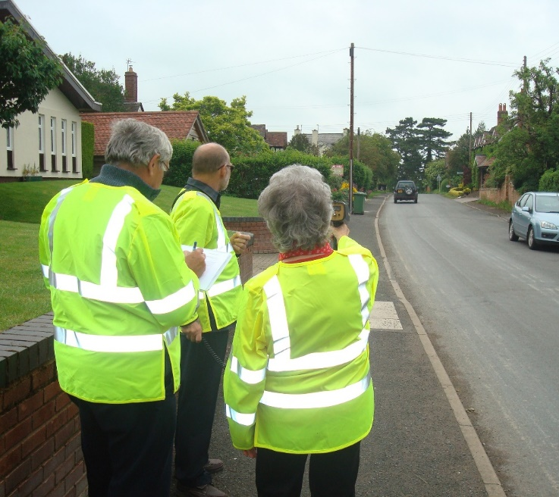

The contacts below may be of interest to those in the parish who may be more comfortable reporting crime or giving information to the police, anonymously:

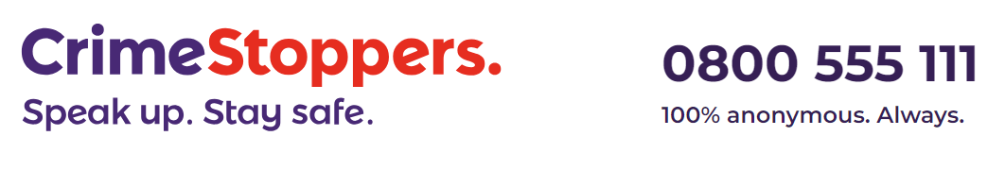
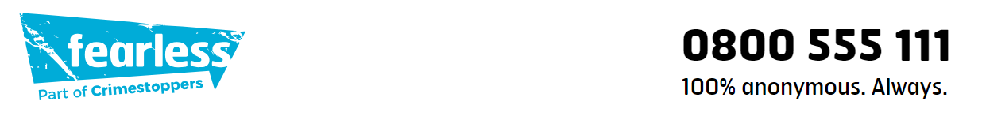

Are your parishioners aware of Action Fraud?

If you’ve been the victim of a scam, fraud or online crime (cybercrime) you can report it to Action Fraud:
- Action Fraud website
- on 0300 123 2040 (Monday to Friday 8am to 8pm).
Action Fraud is the national reporting centre for fraud and cybercrime. It collects reports about fraud on behalf of the police in England, Wales and Northern Ireland. For fraud in Scotland please report it directly to Police Scotland.

