 | On the beat in…  North Shropshire  Market Drayton  Wem  Whitchurch  Safer Neighbourhood Team Newsletter | July 2024

Current statistics on calls to police and crime recording for your neighbourhood can be found at www.police.uk. If you wish to discuss further, please contact a member of your Safer Neighbourhood Team.

Market Drayton – Team contact details:
Team email: marketdrayton.snt@westmercia.police.uk
Safer Neighbourhood Officer: PC Iain McIntosh Mobile: 07811 748 732
Police Community Support Officer: PCSO Andy King Mobile: 07870 163 116
Police Community Support Officer: PCSO Tara Carruthers Mobile: 07971 050 442
Police Community Support Officer: Mobile:

Wem – Team contact details:
Team email: wem.snt@westmercia.police.uk
Safer Neighbourhood Officer: PC Jack Harper Mobile: 07817 885 113
Police Community support Officer: PCSO Lizz Walmsley Mobile: 07967 303 567
Police Community support Officer: PCSO Olly Morris Mobile: 07970 879 117

Whitchurch – Team contact details:
Team email: whitchurch.snt@westmercia.police.uk
Safer Neighbourhood Officer: PC Ben Jones Mobile: 07973 885 557
Police Community Support Officer: PCSO Graeme Baines Mobile: 07890 511 320
Police Community Support Officer: PCSO Dave Andrew Mobile: 07971 395 050
Police Community Support Officer: PCSO Jamie Robinson Mobile: 07967 301 147

Our North Shropshire Parish Councils and their chosen priorities:
Market Drayton |  | Wem |  | Whitchurch
Market Drayton Town | Drugs | Wem Town | Speeding | Whitchurch Town | Drugs
 | ASB |  | ASB |  | ASB
 | ASD |  | Thefts |  | ASD
Adderley | Farm thefts | Wem Rural | Rural Crime | Whitchurch Rural | Speeding
 | Speeding |  | Drugs |  | Thefts
 | Not provided |  | Speeding |  | Other Traffic Offences
Cheswardine | ASB | Hadnall | Speeding | Prees | TBD
 | Dwelling thefts |  | ASB |  | TBD
 | Not provided |  | Out building thefts |  | TBD
Hinstock | Not provided | Shawbury | Speeding | Whixall | Not provided
 | Not provided |  | ASB |  | Not provided
 | Not provided |  | Drugs |  | Not provided
Hodnet | Not provided | Clive | ASB | Ightfield with Calverhall | TBD
 | Not provided |  | Traffic offences |  | TBD
 | Not provided |  | Thefts |  | TBD
Moreton Say | Not provided | Grinshill | Not provided
 | Not provided |  | Not provided
 | Not provided |  | Not provided
Norton In Hales | Not provided | Myddle, Broughton & Harmer Hill | ASB
 | Not provided |  | Criminal Damage
 | Not provided |  | Speeding
Stanton Upon Hine Heath | Speeding | Lee Brockhurst | Farm thefts
 | Farm thefts |  | Speeding
 | Not provided |  | Traffic offences
Stoke On Tern | Not provided | Loppington | Not provided
 | Not provided |  | Not provided
 | Not provided |  | Not Provided
Sutton Upon Tern | Not provided
 | Not provided
 | Not provided
Woore | Speeding
 | Farm thefts
 | ASB
Childs Ercall | Speeding
 | Farm thefts
 | ASB
Weston Under Redcastle | Not provided
 | Not provided
 | Not provided

Please encourage your parishioners to sign up to Neighbourhood Matters.

Sign up to Neighbourhood Matters… your brand-new community messaging service
 | Neighbourhood Matters enables residents, businesses, and community groups to keep in touch with local policing teams. You can choose exactly what type of alert you wish to receive and how you receive them; whether that be by email, text or telephone.  Sign up now at: www.neighbourhoodmatters.co.uk

Hello Parish Councils,

This is your North Shropshire Safer Neighbourhood Team (SNT) Newsletter for June 2024. Please see the link above to police.co.uk for crime recording stats for your area, or any other area in the UK should you wish.

Please get in touch if you would like to discuss anything further, if we can provide more information we will, our contact details are above. If there is anything specific that is affecting your parish area above and beyond the three priorities you have nominated, again please let us know and we will endeavour to support you.

The official West Mercia Police website www.westmercia.police.uk has a wealth of information and includes dedicated sections in relation to News, Recruitment, Watch Schemes, Neighbourhood Matters, Crime Prevention Advice, Support For Victims, other Advice and Information and Thanks & Complaints.

Our North Shropshire SNTs work in a very challenging and varied role and no two days are the same, naturally there are many requests for our time, support and assistance. Obviously, much of what we do we can’t tell you too much about, but rest assured that much of our daily direction and focus is on the three Parish Council Priorities that you provide us with quarterly.

Much of the good work that SNTs engage with are posted in the following places:

- Parish Council reports in person or Newsletters

- Neighbourhood Matters – www.neighbourhoodmatters.co.uk

- Facebook - www.facebook.com/shropshirecops/

- Twitter – www.twitter.com/NorthShropCops

Below is just a small snapshot of the good work North Shropshire SNTs have been involved with recently…

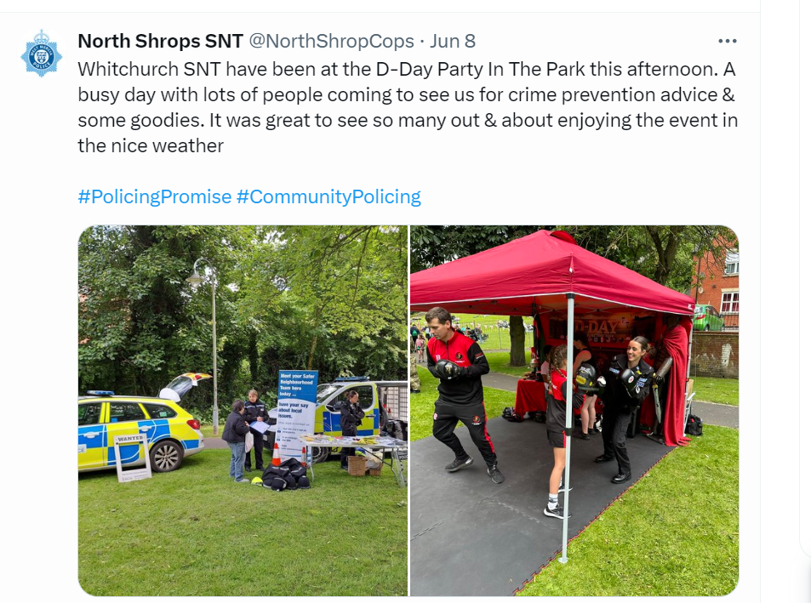

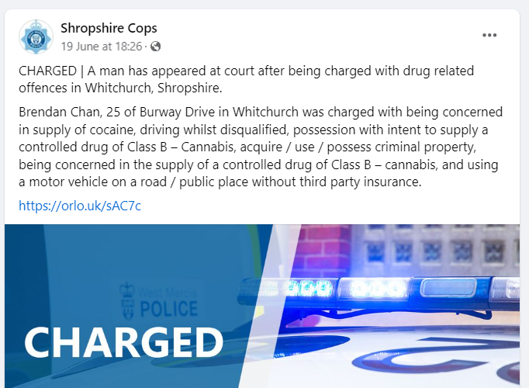

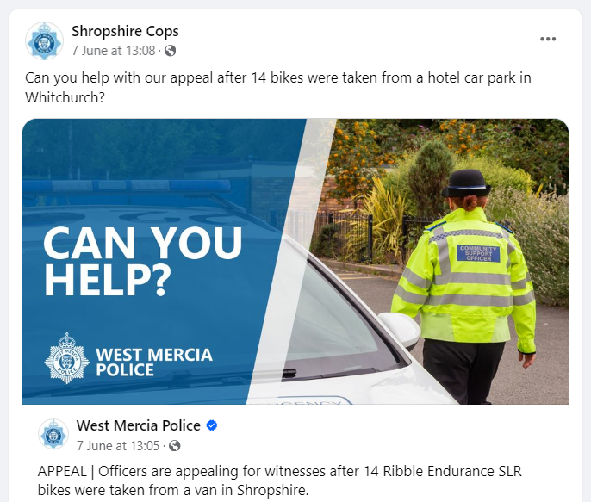

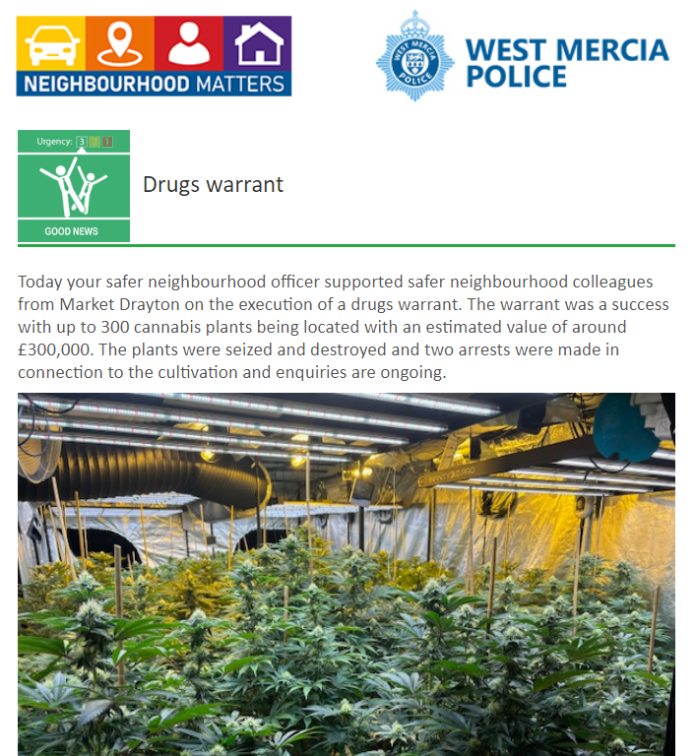

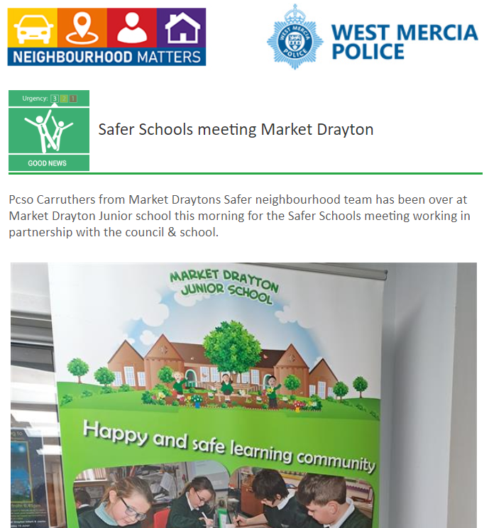

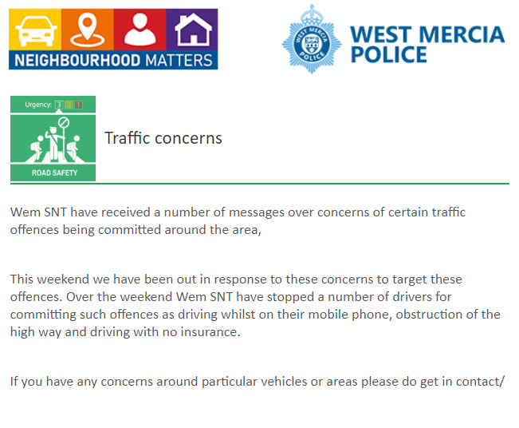

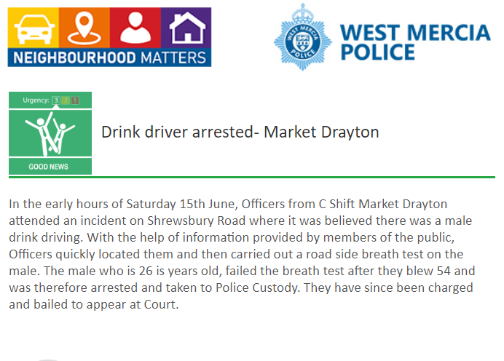

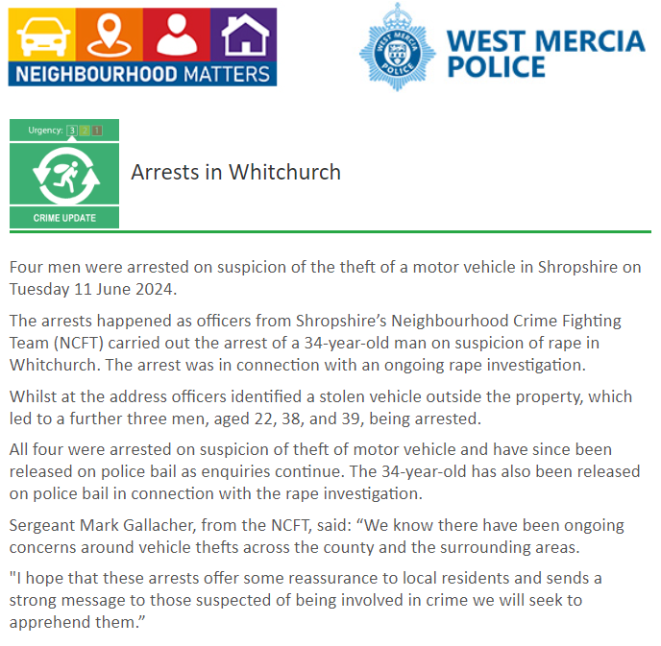

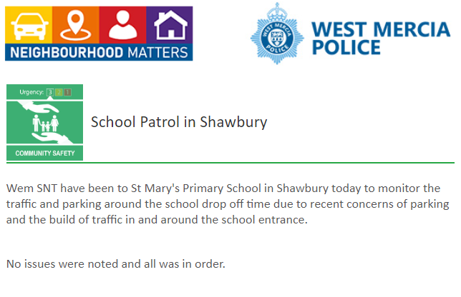

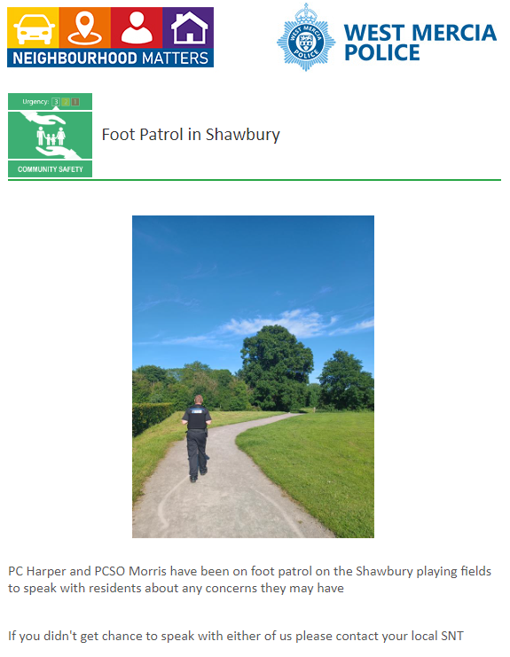

As part of the monthly Newsletter, we will be adding trending and/or appropriate crime prevention advice and information. Along with any recent updates from our other policing departments and partners.

This month’s Newsletter contains sections on ‘Nottingham Knockers’, Anti-Social Behaviour and Distraction burglary: Warning and advice.

‘Nottingham Knockers’


Not sure?
Don’t open the door
‘Nottingham Knockers’ are targeting homes in your area.
Be vigilant. Stay Safe. Do not buy or sell anything at the door.

Who are the Nottingham Knockers?

Nottingham Knockers are usually young men who go door to door, selling household products. They are often dropped off early in the morning in a particular location by a large van and are then transported around that area throughout the day.
What is the scam?
They may offer to show you a fake company I.D for a company that does not exist. They may also be carrying a large holdall style bag which contains various household items at high prices and will try and hard sell to make money. They will also tell you about how they are trying to make a better life.
When you decline their advances, you may be subject to verbal abuse and threats to cause criminal damage.
Not sure? Don’t open the door!
If you get an unexpected knock on the door, please check to see who is on the other side of your door before opening it. Either look through a side window, look through a spy hole, or simply ask out loud who it is. If you do not know them, establish who they are and what they are there for before you open the door. Please remember if the cold caller sales are unsuccessful, they are unlikely to return in future.
If you do experience any verbal abuse and feel intimidated, please call 101 and tell us what was said, and a description of the person.

For the latest crime prevention advice visit: www.westmercia.police.uk/cp/crime-prevention/ @westmerciapolice @wmerciapolice

For crimes in progress call 999.
For non emergencies report online: www.westmercia.police.uk/report
If you are unable to report online, you can contact the police via the 101 non-emergency number.

Anti-Social Behaviour


Some ASB incidents might be an issue for your local council so it may be useful to know to who contact.
Here are some examples of ASB that we want to know about:
- Fireworks misuse (full laws and guidance on our website)
- Abandonment of cars
- Aggressive animals or use of animals in illegal activities
- Nuisance noise from people being inconsiderate in a public space
- Indecent, threatening or offensive phone calls
- Street drinking causing disruptive behaviour
- Vehicle nuisance such as street racing and riding unlicensed powered vehicles
Here are some examples of ASB that isn’t a police matter and your local council could be informed on:
- Someone blocking your driveway
- Stray dog that isn’t sick or injured
- Nuisance noise from pubs and clubs, and construction sites
- General littering, fly-tipping, hazardous items
- Neighbour disputes such as loud music or dogs barking, parking, property boundaries, overgrowing trees and hedges
- Trespassing without causing damage or harm
Full guidance on ASB and the different types can be found here: Antisocial behaviour | West Mercia Police
Or you can find your local council here: Find your local council - GOV.UK (www.gov.uk)
Should you have any concerns about potential ASB, or are experiencing ASB where you live, please contact your local council or if necessary report it to us: Report antisocial behaviour | West Mercia Police
In an emergency, if you or your property are at risk, or a crime is in progress call 999.
If you aren’t comfortable contacting us directly, you can pass on information anonymously to the independent charity, Crimestoppers, by calling 0800 555 111 or by visiting their website: www.crimestoppers-uk.org
Thank you for your help. It is only by the police and the public working together that we can prevent and detect crime.

Distraction burglary: Warning and advice
We have some simple tips to follow which can minimise risk to a distraction burglary and how to deal with ‘cold callers’ at the doorstep:
- If someone knocks on your door, check who it is by looking through a window or peep-hole.
- If it’s not someone you know and trust, or a business caller who has made a pre-arranged appointment – do not open the door! This advice applies regardless of whatever uniform the caller appears to be wearing, the ID card they are carrying or however urgent their business claims to be.
- Tell unexpected business callers to leave and come back later at an agreed time when you have someone else with you.
- In the meantime, check their credentials by calling the organisation they claim to represent. Do so by searching the company name and number online, or in your telephone book. As any number they might have given you could be for an accomplice of a potential offender.
- Report suspicious activity to the police. No matter how small it may seem, your information may help with investigations and prevent legitimate scammers from committing a crime.

Are you aware of Community Speed Watch, and is it relevant to your parish?

With Community Speed Watch now in its eighth year of operation within West Mercia, local communities are being reminded about the scheme and how volunteers can get involved in speed monitoring and improve the quality of life in their area if speeding traffic is causing concern.
Community Speed Watch is a community driven road safety initiative, coordinated by West Mercia Police but managed and run by volunteers in the community. It involves trained volunteers from the community monitoring the speeds of vehicles with approved, hand-held speed measurement devices. Where vehicle speeds are found to be inappropriate, a letter is sent to the registered keeper by the police with the aim of encouraging them to reduce their speed when driving in the future.
The scheme was introduced within West Mercia in 2014 and has gone from strength to strength over the last 8 years with over 40 active sites currently operating. It was introduced to enhance the force’s speed enforcement strategy, by addressing community concerns in areas that do not meet either speed or collision criteria for police-led enforcement.

A Community Speed Watch scheme is initiated when ‘speeding traffic’ has been identified as a community road safety concern by a parish council or Safer Neighbourhood Team. However, several criteria must be met before a scheme can be established:
- The area must have a 30mph or 40mph speed restriction.
- Speed data collected by West Mercia Police must show that speed levels in the area do not meet the national industry requirements for police enforcement.
- No other enforcement activity is currently in place.
- There must be at least six volunteers in each Community Speed Watch scheme.
- Speed checks must be conducted by at least three volunteers at any one time.

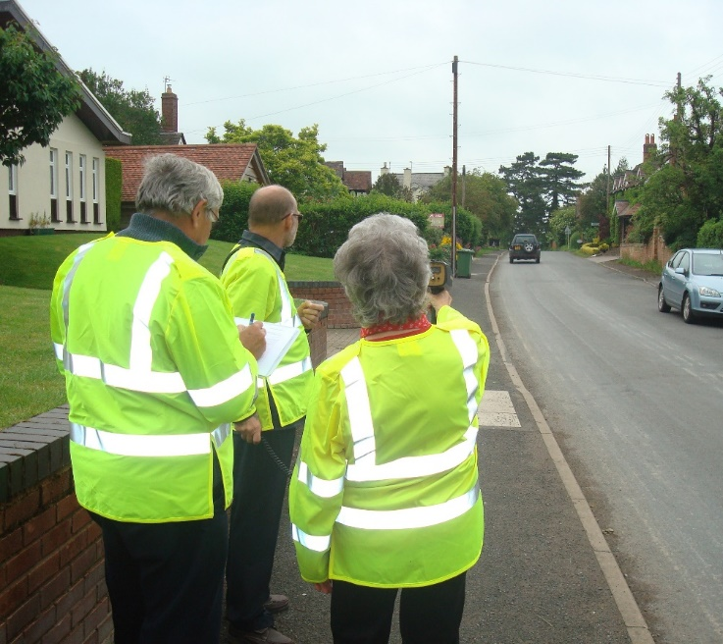

The contacts below may be of interest to those in the parish who may be more comfortable reporting crime or giving information to the police, anonymously:

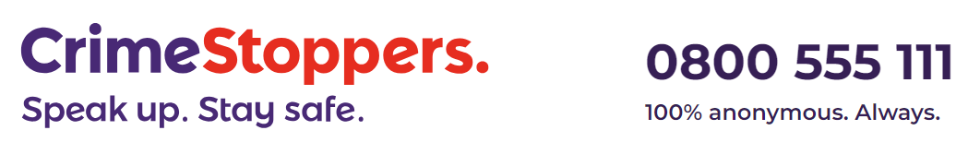
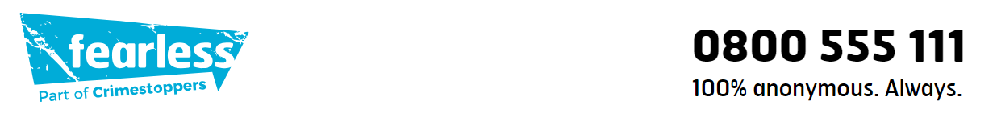

Are your parishioners aware of Action Fraud?

If you’ve been the victim of a scam, fraud or online crime (cybercrime) you can report it to Action Fraud:
- Action Fraud website
- on 0300 123 2040 (Monday to Friday 8am to 8pm).
Action Fraud is the national reporting centre for fraud and cybercrime. It collects reports about fraud on behalf of the police in England, Wales and Northern Ireland. For fraud in Scotland please report it directly to Police Scotland.






